**Requirements and Specification Report**

**Introduction to Software Engineering**

**Fall 2022**

**Group members:**

Wasayef Ashtairy      100053668

Natnael Takele           100058082

Noah Yohannes          100053689

Ahmed Fadhel 100058802

**Instructor:** Dr Davor Svetinovic

**Submission date:** 15/11/2022

Table of Contents

Overview 3

**User Requirements** 3

**System requirements: Functional Requirements** 3

**Non-functional Requirements** 4

**Domain requirements:** 5

Use Case Analysis 5

**Use-cases** 6

**Use-case Diagram** 6

Data Dictionary 11

# Overview

This paper presents the second phase of the child monitoring system, the requirements of this project. First, the user requirements are presented followed by the system requirements, both functional and non-functional requirements. Furthermore, the domain requirements are presented. A detailed use-case analysis is also presented to specify the behaviour of the child monitoring system. Data dictionary and requirement table sections are also presented.

## **User Requirements**

The user requirements are requirements written for the users of this project, that is the parents. Those requirements are described below.

1. The system must provide means to monitor the child’s temperature and send notifications if abnormal temperature readings were obtained.
2. Parents must have the option to view the live video feed on their devices
3. The system must provide and follow security measure and protocols to ensure the family’s privacy and safety from malicious parties.
4. Facility should be provided for the parents to set the baby’s mealtime.

## **System requirements: Functional Requirements**

System requirements are requirements that set out a detailed description of the system’s functions, services, and operational constraints. The system requirements are described below.

1. System should display high-quality live streaming on the screens of remote devices, with the user having complete access to that stream and being able to see it from the camera at any time
2. Notifications received and shown on mobile devices are linked to the system placed on these devices, which alerts parents if their baby's temperature rises beyond 37 degrees, which is considered normal for kid
3. Depending on the seriousness of the notice, a notification can produce a sound and display as a warning if the child's temperature rises to the danger range of 38 degrees or above
4. The system will maintain the baby's room records for the previous 7 days

### **Non-functional Requirements**

The project gives high attention to meeting the non-functional requirements to meet the client’s expectation. The non-functional requirements listed below are considered critical to create an effective product. Hence, these requirements are quantified to make them easily verifiable in the prototyping phase.

1. The system shall maintain the privacy of the information with an authentication system.
2. The system must be accessed only from two accounts, the parents’.
3. The system requires a minimum of 3mbps to send clear audio and video feed.
4. The system shall not be late by more than 10 seconds to send notifications to the parents.
5. The system should not crash more than once in a month.
6. The system should boot in in a time less than 10 seconds.
7. The user should be able to use the system with 30-minutes of training.

### **Domain requirements:**

Requirements that come from the application domain of the

system and that reflect characteristics of that domain

The domain requirements are obtained from the application domain of the baby's monitoring system.

The domain requirements are obtained from the application domain of the baby's monitoring system and represent the features that are characteristic of the baby monitoring system. The domain requirements are presented below.

1. The system monitors only the baby’s room where the camera is installed or otherwise the system will be useless.
2. The system must follow all national privacy regulations because the rights of the user (the data subject) are protected by privacy laws with regard to the fair and legal acquisition and use of their private details by organizations.

# Use Case Analysis

The use-case analysis presented below defines the behaviour of the child monitoring system.

***Actors:*** There are two groups of actors for our system.

***Primary actors:***

* The parents
* The monitoring software(system)

***Secondary actor:***

* The camera system

## **Use-cases**

* Login
* Open live feed
* Display data from the camera system
* Send notifications

## 

## **Use-case Diagram**

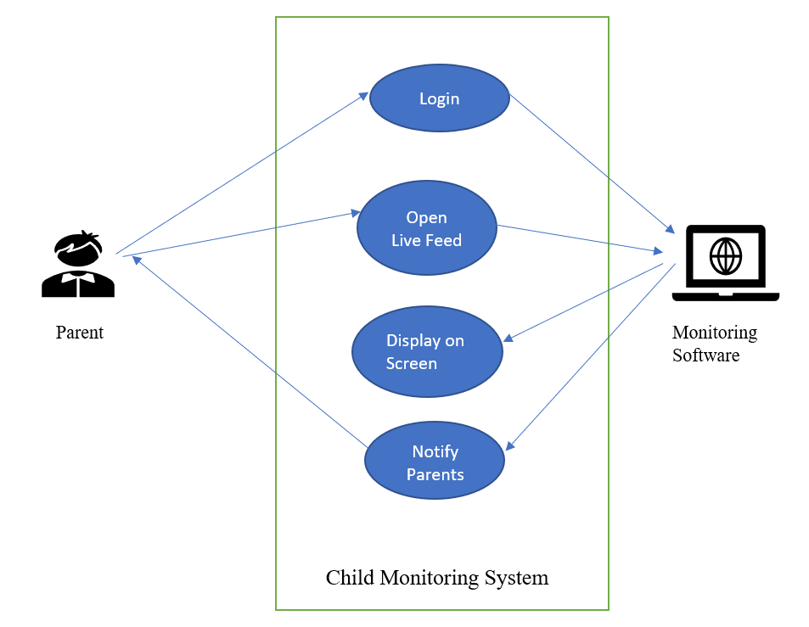

**Use Case 1:**

* ***Name:*** Login to the system
* ***Description:*** The login/register use case is realized in this use case. The user must first choose whether they are a first-time user or have an account. Second, if the user already has an account, it will open in a matter of seconds. If not, a registration form will ask the user to provide a username and password. Finally, the screen will display the live stream.
* ***Actors:*** User (Parents), system
* ***Pre-Conditions:*** User is logged in
* ***Post-Conditions:***

The system has successfully registered the user.

The user has access to the system's functionality.

* ***Successful path:***

1- If the user is new, it requests user to be registered.

2- The system requests the user's personal information.

3- The user provides personal information, including the desired credentials (username/password), and submits the registration process.

4- The system distinguishes between various users and stores them in the system database accordingly, and registration is successful.

* ***Alternative path:***

- Invalid Username/Password

If the system cannot discover the name or the password during the basic flow, an error message is presented. When there are more than two people registered, the system displays an error indicating that the number of users has exceeded the limit. The actor has the option of entering a new name or password, or cancelling the procedure, at which time the use case closes.

* ***Exceptions:*** No or very slow internet connection.
* ***Rules:***

No more than 2 users can register in the system

Username must be different than the password

**Use Case 2:**

* ***Name:*** Open Live-Feed
* ***Description:*** After logging in the user is given options to choose from. One of these options is Open Live-Feed. The feed of the child with the temperature signal in case said child has a fever are displayed live after choosing it.
* ***Actors:*** User & System
* ***Pre-Conditions:*** User is logged in.
* ***Post-Conditions:*** The live feed is displayed.
* ***Successful path:***

1. Live Feed is displayed.
2. If the child temperature is high, a signal appears on the feed.

* ***Alternative path:***

The hardware might not be working or at least not properly, so nothing is displayed.

* ***Exceptions:*** Internet connection being not available. Hardware not working.
* ***Rules:***

No more than 2 accounts can view the live feed at the same time. The users must be logged in. The devices must be connected to the internet.

**Use case 3:**

* ***Name***: Display video on the screen
* ***Description***: The monitoring system will fetch the video and audio data from the remote camera system and display it on the screen. First, the parents select open feed. If the camera system in the child’s room is connected to the monitoring software, the video will be displayed on the screen.
* ***Actors***: User (Parents), The monitoring system, The camera system
* ***Pre-Condition***: at least one parent is logged in
* ***Post***-***Condition***: parents can see the live video feed
* ***Successful*** ***path***:

1. Parents Login request

2. Monitoring software displays available options to parents

3. Parents choose open live feed

4. the system opens the data from the camera system

5. Parents can now see the real-time feed

* ***Alternative*** ***path***:

1. Error message will be displayed for invalid credentials following step 1

2. Data such as video, audio, not available from the camera system following step 3

* ***Exceptions***

1. No feed from the camera system. The system is disconnected

* ***Rules***

System needs to be active all the time

**Use Case 4:**

* ***Name:*** Send notification
* ***Description:*** The notification use case is realized in this use case. The system receives live temperature recording as an input from the baby’s room. Out of the ordinary temperature levels are sensed by the system and immediately the system sends notification to the parents. Moreover, when the baby’s mealtime approaches the system notifies the parents.
* ***Actors:*** User, System
* ***Pre-Conditions:*** User is logged in, parents have set baby mealtimes
* ***Post-Conditions:*** System successfully sends notification to the parents.
* ***Successful path:***

1- The system receives temperature reading from the camera as an input

2- The system decides if the temperature reading is out of the range of healthy child’s temperature reading.

3- The system sends notification to the parents.

4- The system keeps track of time.

5- It sends notifications/reminders to the parents indicating it’s the baby’s mealtime, according to time intervals set by the parents while configuring the system.

* ***Alternative path:***

If the system doesn’t detect a temperature recording that is not out of the ordinary, it will only provide the temperature reading in the notification section.

* ***Exceptions:*** Without an internet connection the system will not be able to send a notification to the parents.
* ***Rules:***

There must be a constant temperature recording input to the system. Thus, there must be a strong internet connection.

The baby mealtimes must be already set by the parents.

# Data Dictionary

|  |  |  |  |
| --- | --- | --- | --- |
| Name | Description | Type | Date |
| Users | the names of the users with a login account  who will use the system | Entity | 10.11.2022 |
| System engineer | the person that develops and maintains the  system | Entity | 10.11.2022 |
| camera | A device setup  system up in the child’s room | Entity | 10.11.2022 |
| Alert system | A way of displaying notification on screen | Attribute | 10.11.2022 |
| Data storage | A way to keep older recordings of the child’s room | Attribute | 10.11.2022 |

**Requirements table**

|  |  |  |  |  |
| --- | --- | --- | --- | --- |
| Baby Monitoring System Requirements | | | | |
| # | Id | Name | Text | Satisfied By |
| 1 | S0.0 | Original Statement | - A Client login/register to the baby monitoring system  - System receives video feed.  - User opens video feed  - Display video on screen  - System sends notification |  |
| 2 | S1.0 | User registration/logging | User registration/logging in is performed by the system | System |
| 3 | S2.0 | Live video feed | Video is recorded by the cameras | System cameras |
| 4 | S3.0 | Display video on screen | System displays video screen | System, client’s devices |
| 5 | S4.0 | Cameras sense temperature | System cameras senses temperature | System cameras |
| 5 | S5.0 | Notification | The system sends notification | System |

**Github Repository link:** [**Baby-Monitoring-System**](https://github.com/Noah-Yohannes/Baby-Monitoring-System)